ACTIVITY REPORT

From June 17 until June 22, 2024 we held the activity International Trading camp in Ruse, Bulgaria.

During the 6 days our team, consisting of 32 people including: staff, beneficiaries and the IT team) participated in activities according to the activity plan set in the projext.

**Day 1**

- activities planned: starting at 16:30 we attended a briefing in the conference room of the lodgement complex, it was a coordinating meeting organized by the local coordinator, in which we were informed about the program with details for the next 5 days. From 17:30 a specialist instructor took his turn to show us some theoretical aspects regarding the activities and instruments needed for the practical training we would attend in order to prepare us for the map orientation activity. Also, the expert form the local managerial team introduced us to a historical framework of the town and of the area around the town of Ruse.

- achievements: the participants were thoroughly informed about the program for each day of the tour, about how to use the map and the compass during the training session and the map orienteering contests . The participants learned about the historical phases, facts, events and heroes that have had a significant contribution to the existence and the development of the Ruse region.

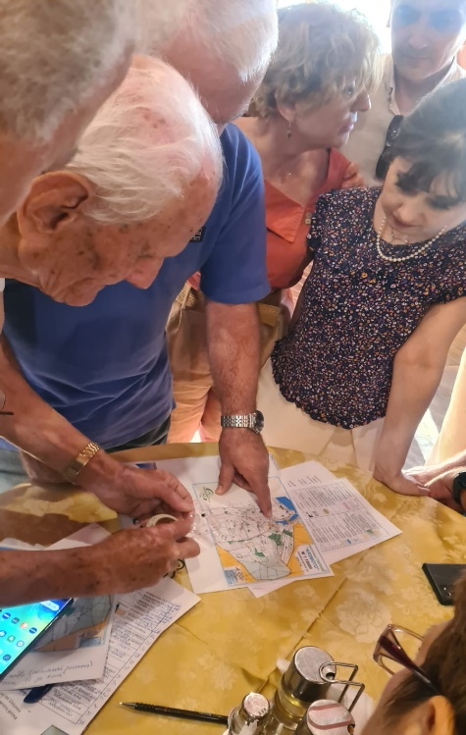

**Day 2**

activities planned: starting at 9:15 in the Nikolovo natural park we had theoretical training and after that we had a session of orienteering practical training for map reading and starting from 16:00 we had a practical exercise on a preset path. Activities have been conducted by instructors of the Map Reading Club from “Compass Cross” Orienteering Class in Ruse…

- achievements: the participants learned to use the topographic details on the map, how to use the compass to establish the checkpoint, to be able to … orientate themselves on the map with the cardinal points and to move in the terrain in order to discover the signs placed on the track on the starting line and the finish line.

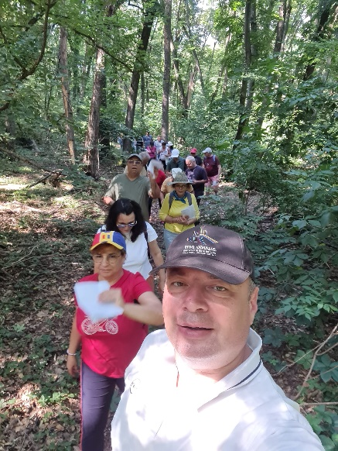

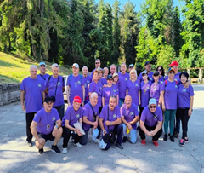

Day 3

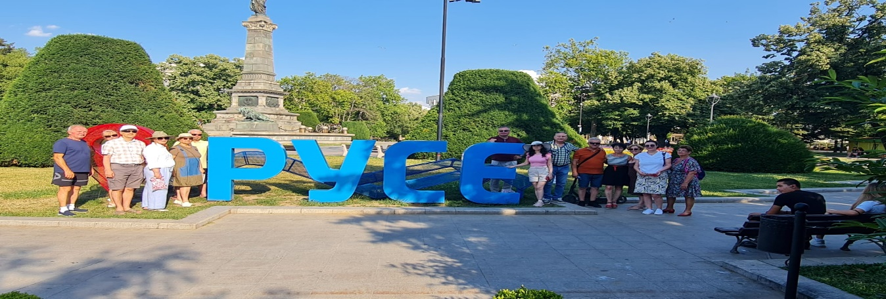

- activities planned: We started at 9:45 the map reading contest coordinated by the coaching of the instructors from the Map reading Club “Compass Club”, after that we visited the Ruse town. At 18:00 the Romanian team began the planned activities for the Romanian Day event - we presented some aspects of the history of Romania ,places, the special geographical features and we introduced some of the famous places in our country and we also taught our bulgarian colleagues some Romanian Traditional Folk Dances.

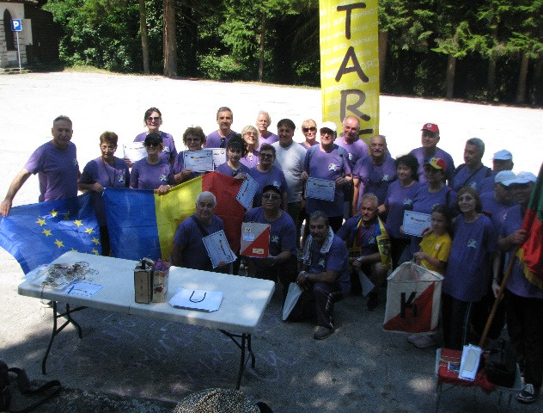

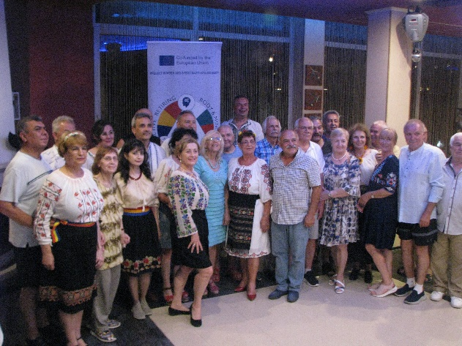- achievements: We Used the acquired knowledge and we applied it on the field everything that we have learned during the sessions of theoretical and practical training of orienteering. Each Participant used the map and the compass individually on the track set by the instructors and referees. At the end we received certificates of participation that were handed over to us by the Mayor of the Nikilovo commune in Bulgaria.We visited some of the touristic attractions and representative monuments of Ruse Town. During the Romanian Evening we promoted our history, culture and values of the Romanian people and we were dressed in the well-known Romanian blouse called “Iie”, we presented all this information and the participants from the Bulgarian team learned two Romanian Traditional Folk Dances.

Day 4

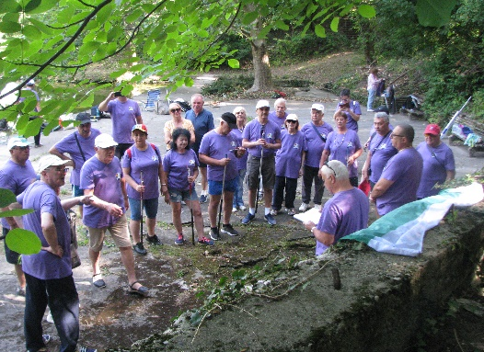

-activities: at 09:30 we had training meeting and after that we participated in a fishing contest on the lake in the natural park of Nikolovo under the guidance of a speciality instructor.

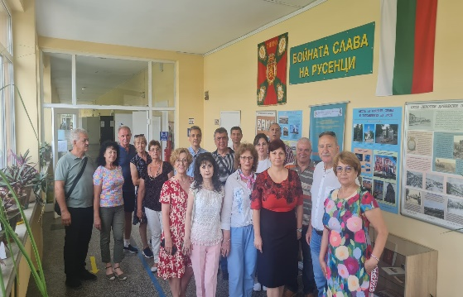

Starting with 14:00 we visited the Friedrich Schiller High School - a German language high school-in Ruse.

Later, at 18:00 we participated in the Bulgarian Day organized by the Bulgarian team.

* 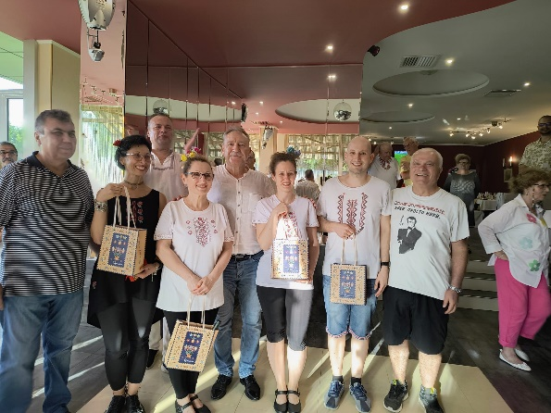achievements: Participants have learned information regrading the species of fish living in the waters of Bulgaria and the techniques and tools for sports fishing are used.  
  The High School Principal informed us about the results of the collaboration between them and the Association of Reserve Troops in Ruse who from time to time run a program of Patriotic Training and teaching of the History of Bulgaria with the students in their high school. High School Principal accepted our proposal to start a collaboration with a high school in the locality of Goagiu, the county of Hunedoara in Romania who has a protocol agreement with a branch of our association in that county.

We discovered common values that link both our history and culture and we learned two traditional bulgarian dances from Bulgarian dance instructors.

Day 5

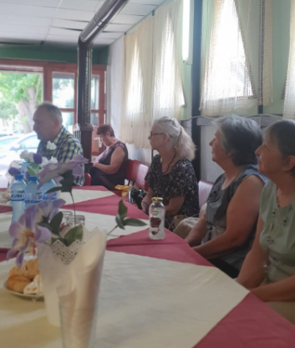-activities: At 10:00 we started to visit the Senior Club “The Friendship” in Ruse town.  
We were presented the projects ran by the Club for the benefit of the elders, the way the club collaborates with local authorities and with Red Cross in Bulgaria and the contracts they have with different similar organizations abroad.  
We visited the Dimitrie Basarabov Monastery close to the Ruse Town.

[WhatsApp Video 2024-07-08 at 19.34.10_BULGARIAN EVENING.mp4](WhatsApp%20Video%202024-07-08%20at%2019.34.10_BULGARIAN%20EVENING.mp4)

-achievements: We acquired information about activities that can be run with seniors in order to combat a sedentary lifestyle and to maintain themselves in a good mental state and a good physical shape.  
We also learned about the way we can work together with local authorities and what projects we can run for the benefit of the seniors together with the Red Cross.

We also visit the Dimitrie Basarabov Monastery we found an impressive monument of cultural and religious christian orthodox significance.

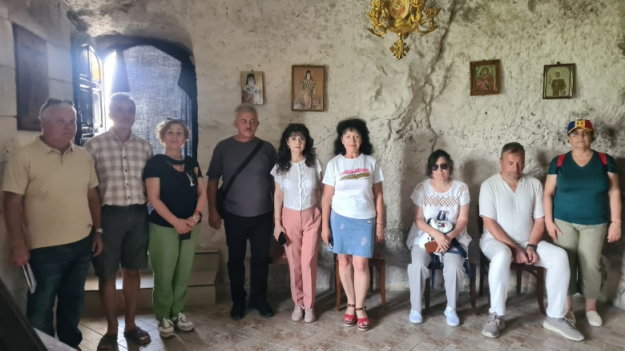Both teams identified common Christian values of both out countries, taking into account the fact that Saint Dimitrie Basarabov is the Saint Patron that protects Bucharest, the capital city of our country.

The allocated budget for this activity have been spent in its entirety.  
  
  
Local Project Manager  
President of Ronorur  
Veselin Dodev